Chapel by the Sea
Presbyterian Church (USA)
5thSunday after Pentecost/
Communion Sunday
July 5, 2020

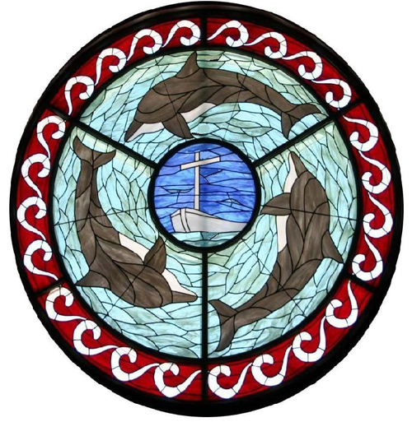

Chapel by the Sea was the first church on our island and remains a church for the community, welcoming all people seeking to know and serve Christ. We are a mission for Jesus Christ and church for all seasons…
…seasons of life
…seasons of the year
…seasons of our growth as Christians

A WORSHIP SERVICE FOR THE LORD’DAY

TOLLING OF THE BELL

WELCOME AND ANNOUNCEMENTS Rev. Dr. Stephen D. Adkison

Prelude America The Beautiful Arr. by Joel Raney
Piano Solo

CALL TO WORSHIP
One: Peace be with you
All: And also with you
One: Let us praise the Lord!
All: The Lord’s name be praised!

*HYMN #554 (All Verses) Let All Things Now Living ash grove

- Let all things now living A song of thanksgiving
To God our Creator triumphantly raise;
Who fashioned and made us, Protected and stayed us,
By guiding us on to the end of our days.
God's banners are o'er us, Pure light goes before us,
A pillar of fire shining forth in the night: Till shadows have vanished,
All fearfulness banished, As forward we travel from light into Light.

- By law God enforces. The stars in their courses,
The sun in its orbit obediently shine; The hills and the mountains,
The rivers and fountains, The depths of the ocean proclaim God divine.
We, too, should be voicing Our love and rejoicing
With glad adoration, a song let us raise: Till all things now living
Unite in thanksgiving, To God in the highest, hosanna and praise.

CALL TO RENEWAL Dr. Adkison
“If we say we have no sin, we deceive ourselves, and the truth is not in us. If we confess our sins, He is faithful and just, and will forgive our sins and cleanse us from all unrighteousness.” Let us confess our sins to God and to one another….

PRAYER OF RENEWAL Dr. Adkison
Eternal and merciful God, we remember how you, through Jesus Christ, died on the Cross and were raised to a new life for us, your children. We humbly approach your throne of grace, seeking the forgiveness of all that separates us from you. As we prepare to break the bread and drink from the cup, let your Spirit purify our hearts and our minds and grant us all your wholeness and spiritual healing. We open our mouths and receive the bread and the cup of life. We open our hearts and receive your forgiveness. In Jesus’ name we pray, Amen.

GOOD NEWS OF FORGIVENESS Dr. Adkison
Jesus gave the most extravagant gift of all - the offering of himself for us.
Through this selfless gift, we are set free, and our sins are forgiven.
Our thanks be to God!

(Please rise and let us sing)

*GLORIA PATRI
Glory be to the Father, and to the Son, and to the Holy Ghost;
As it was in the beginning, is now, and ever shall be,
World without end. A – men, A – men.

PRAYER OF ILLUMINATION

ANTHEM Seek Ye First Traditional
Solo: Diana Means

SCRIPTURE READINGS Ephesians 4:26-27 (NIV)

26 “In your anger do not sin”: Do not let the sun go down while
you are still angry, 27 and do not give the devil a foothold.

May these words of my mouth and
this meditation of my heart
be pleasing in your sight,
O Lord, my Rock and my Redeemer.
Thanks be to God!

SERMON “Taming Your Temper” Dr. Adkison

THE SACRAMENT OF COMMUNION
Invitation to the Lord’s Table

THE WORDS OF INSTITUTION
The Breaking of the Bread
The Pouring of the Cup

PASTORAL PRAYER & THE LORD’S PRAYER
Our Father who art in heaven, hallowed be thy name.
Thy kingdom come, thy will be done, on earth as it is in heaven.
Give us this day our daily bread; and forgive us our debts,
as we forgive our debtors; and lead us not into temptation, but deliver us from evil. For thine is the kingdom, the power, and the glory, forever. Amen.

*HYMN #509 (All Verses) For the Bread Which You Have Broken kingdom

1. For the bread which You have broken,
For the wine which You have poured,
For the words which You have spoken,
Now we give You thanks, O Lord.

- By this promise that You love us,
By Your gift of peace restored,
By Your call to heaven above us,
Hallow all our lives, O Lord.

- With the saints who now adore You,
Seated at the heavenly board,
May the church still waiting for You,
Keep love’s tie unbroken, Lord.

- In Your service, Lord, defend us;
In our hearts keep watch and ward;
In the world to which You send us,
Let Your kingdom come, O Lord.

*BENEDICTION

*CONGREGATIONAL RESPONSE Go Now In Peace D. Besig
Go Now In Peace, Never Be Afraid.
God Will Go With You, Each Hour Of Every Day.
Go Now In Faith, Steadfast, Strong And True.
Know He Will Guide You In All You Do.
Go Now In Love, And Show You Believe.
Reach Out To Others, So All The World Can See.
God Will Be There, Watching From Above.
Go Now In Peace, In Faith, And In Love.
Amen, Amen, Amen.

*POSTLUDE Polonaise in A by Frederick Chopin

*Denotes standing, if able.
Copyrights observed through Christian Copyright Licensing International – CCLI # 29921

Prayer Guide ⎯ July 5, 2020

- Please pray for…
- Doug Greer
- Marie, Jeanne, Aubrey & Stefan
- Linda Brown
- Anita Adkison
- Roger & Karen Rhude
- John & Julianna Beal
- Fred & Barb Giuffreda
- The Bob Horning Family
- Amy Bell Finiki
- Lowell Spiess
- John Berkenpas
- Alta Nodland
- Jean Clark
- Jean Wahl
- Karin, Penny & Matt & Families
- Drew Vandlen
- Jim Silvernail
- Audrey Berkenpas
- Joy Booth
- Chuck Golden
- Maria Werner
- Chris M.
- Amanda volunteering in Africa
- Aubrey
- Peggy Huff
- David Conrad
- Graelie Grant
- Josh Stevens, USN
- Craig & Laurie Furlong
- Bob & Ginny Lemire
- Bushnell Family
- Fasick, Bennett, Rhodus & Eggar Families
- Sidok Family
- Chris Foster
- Kathy Frazee
- Linda Hinrichs
- Brad & Pam Cox
- Deb, Connie, Alan
- Greg Beller
- Craig Allen
- Lauren & Marilyn Kamm
- Mary Pratt
- Jarrod Karnes
- Katie Spyke
- Haas Family
- Jay Dishnow
- Merlyn O’Malley
- Doris Lynch
- R.J. & Family
- Tim & Karen
- LaCombe Families
- Unspoken

Staff: The Rev. Dr. Stephen D. Adkison, Pastor/Head of Staff (skypilot_mdiv@hotmail.com;
Cell: 573-822-8695)
Michael Melnikov, Director of Music/Organist
Ann Fossum, Parish Nurse (ann@chapelbts.org)
Denise Armstrong, Office Administrator
Holly Tribble, Administrative Assistant
Philip Jordan, Facilities Manager
Darren Harkulich, Sexton
Vacant, Audio/Visual Booth
The Rev. Don Jafvert, Pastor Emeritus
Chapel Phone (239) 463-3173
*chapel@chapelbts.org *www.chapelbts.org; 100 Chapel, FMB, FL 33931

