Chapel by the Sea
Presbyterian Church (USA)
7thSunday after Pentecost
July 19, 2020

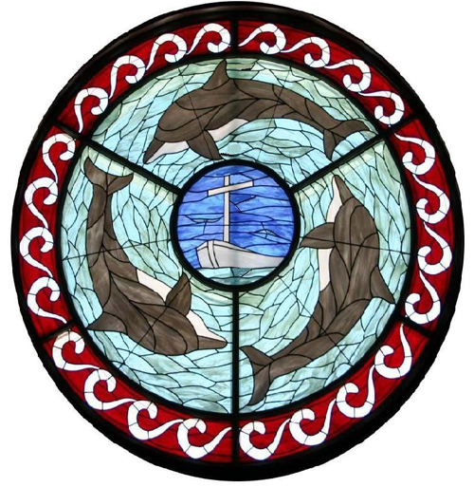

Chapel by the Sea was the first church on our island and remains a church for the community, welcoming all people seeking to know and serve Christ. We are a mission for Jesus Christ and church for all seasons…
…seasons of life
…seasons of the year
…seasons of our growth as Christians

A WORSHIP SERVICE
FOR THE LORD’DAY

TOLLING OF THE BELL

WELCOME AND ANNOUNCEMENTS Rev. Dr. Stephen D. Adkison

Prelude Canon in D by Pachelbel

CALL TO WORSHIP

*HYMN #366 (All Verses) Jesus, Thy Boundless Love to Me St. Catherine

¹ Jesus, Thy boundless love to me,
No thought can reach, no tongue declare;
O knit my thankful heart to Thee,
And reign without a rival there!
Thine wholly, Thine alone, I’d live,
Myself to Thee entirely give..

² O grant that nothing in my soul
May dwell, but Thy pure love alone;
O may Thy love possess me whole,
My joy, my treasure, and my crown!
All coldness from my heart remove;
May every act, word, thought be love.

³ O Love, how gracious is thy way!
All fear before Thy presence flies;
care, anguish, sorrow, melt away,
Where'er Thy healing beams arise.
O Jesus, nothing may I see,
Nothing desire or seek, but Thee.

CALL TO RENEWAL Dr. Adkison
“If we say we have no sin, we deceive ourselves, and the truth is not in us. If we confess our sins, He is faithful and just, and will forgive our sins and cleanse us from all unrighteousness.” Let us confess our sins to God and to one another….

PRAYER OF RENEWAL Dr. Adkison
O God, early in the morning I cry to You.
Help me to pray and to concentrate my thoughts on You:
I cannot do this alone. In me there is darkness,
but with You there is Light.
I am lonely, but You do not leave me;
I am feeble in heart, but with You there is Help.
I am restless, but with You there is Peace.
In me there is bitterness, but with You there is Patience.
I do not understand Your ways, but You know the Way for me.
Restore me to liberty, and enable me to live now.
That I may answer before You and before me.
Lord, whatever this day may bring, Your name be praised, Amen.
(Dietrich Bonhoeffer, Lutheran Pastor and Theologian)

GOOD NEWS OF FORGIVENESS Dr. Adkison
Jesus gave the most extravagant gift of all - the offering of himself for us.
Through this selfless gift, we are set free, and our sins are forgiven.
Our thanks be to God!

(Please rise and let us sing)

*GLORIA PATRI
Glory be to the Father, and to the Son, and to the Holy Ghost;
As it was in the beginning, is now, and ever shall be,
World without end. A – men, A – men.

SCRIPTURE READINGS 1 John 4:16-21

¹⁶ And so we know and rely on the love God has for us. God is love. Whoever lives in love lives in God, and God in them.
¹⁷ This is how love is made complete among us so that we will have confidence on the day of judgment: In this world we are like Jesus.
¹⁸ There is no fear in love. But perfect love drives out fear, because fear has to do with punishment. The one who fears is not made perfect in love.
¹⁹ We love because he first loved us.
²⁰ Whoever claims to love God yet hates a brother or sister is a liar. For whoever does not love their brother and sister, whom they have seen, cannot love God, whom they have not seen.
²¹ And he has given us this command: Anyone who loves God must also love their brother and sister.

May these words of my mouth and
this meditation of my heart
be pleasing in your sight,
O Lord, my Rock and my Redeemer.
Thanks be to God!

SERMON “Perfect Love Casts Out Fear” Dr. Adkison

PASTORAL PRAYER & THE LORD’S PRAYER
Our Father who art in heaven, hallowed be thy name.
Thy kingdom come, thy will be done, on earth as it is in heaven. Give us this day our daily bread; and forgive us our debts, as we forgive our debtors; and lead us not into temptation, but deliver us from evil. For thine is the kingdom, the power, and the glory, forever. Amen.

ANTHEM Hannah Adkison, Soloist

*CONGREGATIONAL RESPONSE Go Now In Peace D. Besig
Go Now In Peace, Never Be Afraid.
God Will Go With You, Each Hour Of Every Day.
Go Now In Faith, Steadfast, Strong And True.
Know He Will Guide You In All You Do.
Go Now In Love, And Show You Believe.
Reach Out To Others, So All The World Can See.
God Will Be There, Watching From Above.
Go Now In Peace, In Faith, And In Love.
Amen, Amen, Amen.

*BENEDICTION

*POSTLUDE Postludium by J.S. Bach

*Denotes standing, if able.
Copyrights observed through Christian Copyright Licensing International – CCLI # 2992

Prayer Guide ⎯ July 19, 2020

Please pray for…
- Harry Willard
- Doug Greer
- Marie, Jeanne, Aubrey & Stefan
- Linda Brown
- Anita Adkison
- Roger Rhude
- John & Julianna Beal
- Fred & Barb Giuffreda
- The Bob Horning Family
- Amy Bell Finiki
- Lowell Spiess
- John Berkenpas
- Alta Nodland
- Jean Clark
- Jean Wahl
- Karin, Penny & Matt & Families
- Drew Vandlen
- Jim Silvernail
- Audrey Berkenpas
- Joy Booth
- Chuck Golden
- Maria Werner
- Chris M.
- Amanda volunteering in Africa
- Aubrey
- Peggy Huff
- David Conrad
- Graelie Grant
- Josh Stevens, USN
- Craig & Laurie Furlong
- Bob & Ginny Lemire
- Bushnell Family
- Fasick, Bennett, Rhodus & Eggar Families
- Sidok Family
- Chris Foster
- Kathy Frazee
- Linda Hinrichs
- Brad & Pam Cox
- Deb, Connie, Alan
- Greg Beller
- Craig Allen
- Lauren & Marilyn Kamm
- Mary Pratt
- Jarrod Karnes
- Katie Spyke
- Haas Family
- Jay Dishnow
- Merlyn O’Malley
- Doris Lynch
- R.J. & Family
- Tim & Karen
- LaCombe Families
- Unspoken

Staff: The Rev. Dr. Stephen D. Adkison, Pastor/Head of Staff (skypilot_mdiv@hotmail.com;
Cell: 573-822-8695)
Michael Melnikov, Director of Music/Organist
Denise Armstrong, Office Administrator
Holly Tribble, Administrative Assistant
Philip Jordan, Facilities Manager
Darren Harkulich, Sexton
Vacant, Audio/Visual Booth
The Rev. Don Jafvert, Pastor Emeritus
Chapel Phone (239) 463-3173
*chapel@chapelbts.org *www.chapelbts.org; 100 Chapel, FMB, FL 33931

